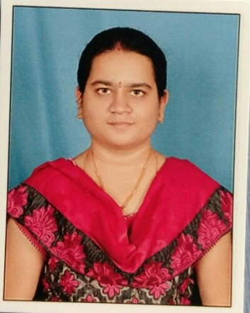
 | Name of the Faculty : | L.BHAVYA
 | Department : | COMPUTER SCIENCE AND ENGINEERING
 | Designation : | AD HOC LECTURER
 | Contact details | E-mail: bhavyalevadala@gmail.com  Phone: +91 9573461354
- Introduction
Educational Qualification  B-Tech  M-Tech  Ph.D | year of passing  2013  2015  -
Work Experience  -Teaching  -Research  -Industry | Years of Experience (1)  1  -  -
Areas of Specialisation | CSE
No .of Papers Published | National Journals: 00  International Journals: 01  National Conferences: 01  International Conferences : 01
Professional Membership | ---
Ph.D Guided | ---
Projects sponsored | ---
Patents | ---
No. of Books published with details | ---
No of Conferences/workshops/
symposiums organized
No. of Workshops/FDP attended | 2
Reviewer for Reputed journals | --
Awards if any: | --

- Conferences/ paper Publications
- L.Bhavya, IJCAE published my journal in volume3 issue3 on the topic “Software Testing Analysis” (ISSN NO: 0988 – 0382E) - 2012
- Attended a Joint International conference on ICAIECES-2017 & ICPCIT-2017 on the topic “High Security to mails by using Thumb”, MITS Madanapalle in 2017.

- Seminars

Enter all the Seminars you attended both National and International

- Workshops
- Attended a Workshop on “cloud computing & its applications”, SV university, Tirupathi in 2013
- Attended a One week FDP Program at malla reddy engineering college (Autonomous), Hyderabad on HTML5 and PYTHON PROGRAMMING in 2016.
- Attended a Workshop on “National cyber safety and security standards summit ‘17”, Bits pilani – Hyderabad campus in 2017.
- Attended two day national workshop on “Teaching Dynamics for Engineering Faculty”, JNTUACEP in 2017

- Books

- Conferences organised

